Experiment Title 1.3

**Student Name: ADITYA RAJ UID: 21BCS8948**

**Branch: Computer Science Engineering Section/Group: 703 A**

**Semester: 3RD Date of Performance: 02/09/2022 Subject Name: Database Management System Subject Code: 21CSH-214**

1. **AIM**: Write a pl/sql program to whether a number is odd or even.

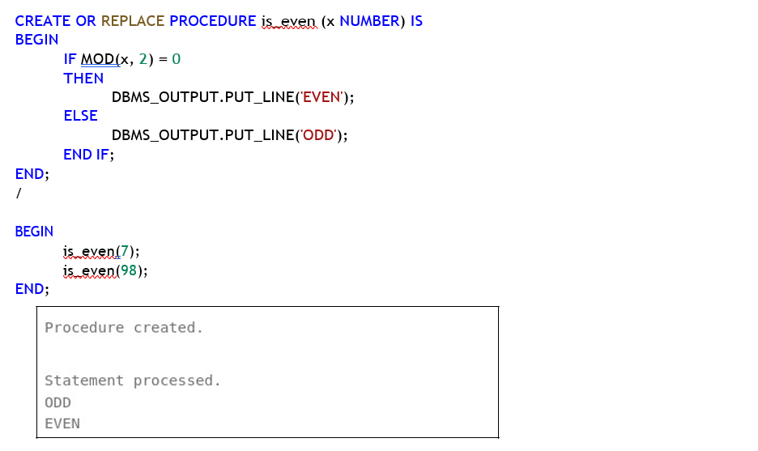

**2.Aim-** Write a pl/sql program to find area and perimeter of a rectangle

